## **Project “Dragon” 1-Page GDD**

*Diablo meets Monty Python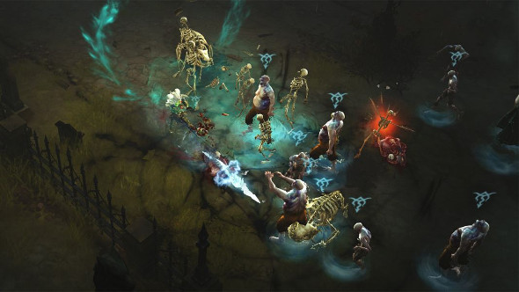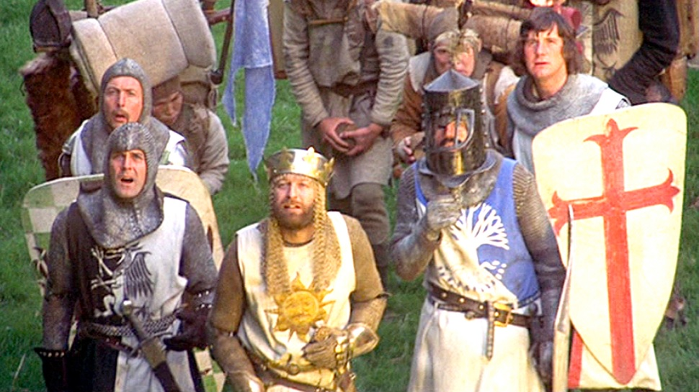*

**Genre:** RPG, 3rd person fixed camera RPG.  
**Target Audience:** T for Teen.

**Controls:** Mouse & keyboard and controller

**Thematic Setting:** Medieval fantasy – swords, knights, dragons

**Tech Stack:** Unity 5+, Blender, Gimp / Photoshop, Audacity

**Platform(s):** Steam

**Game Moment:** 2 minutes of simple level flow, basic combat (hitting and taking damage) with multiple enemy types.

**Game Summary:**

**Core Player Experience:**

**Central Theme:**

**Design Pillar:**

**Anticipated Remarkability:**

**Anticipated Steam Early Access Launch date:**

**Feature Development Priorities:**

**Comparative Products:**